Exp 1 : Basic File and User Management Commands

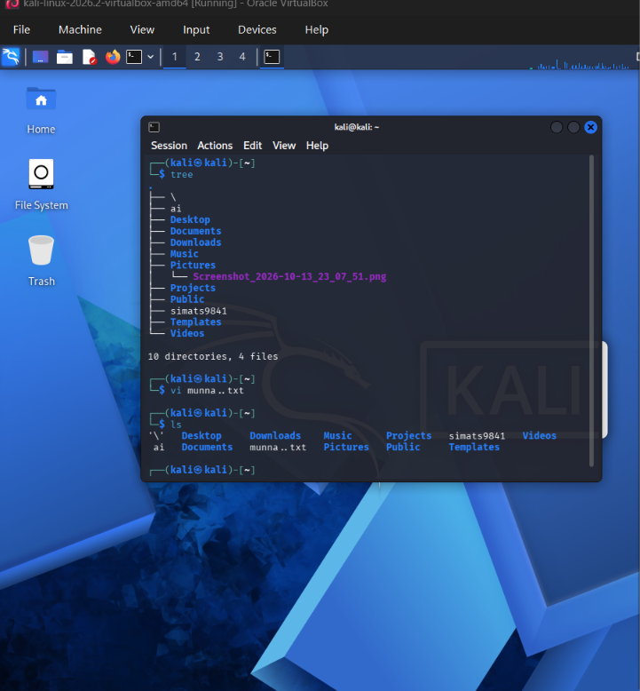

Experiment 2

File Viewing Commands

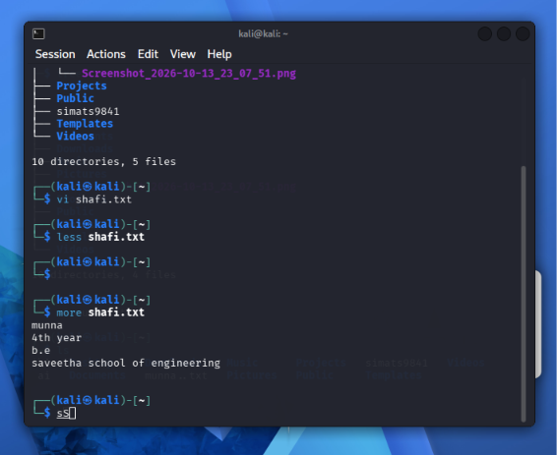

Experiment 3

Tree, Head and Tail Commands

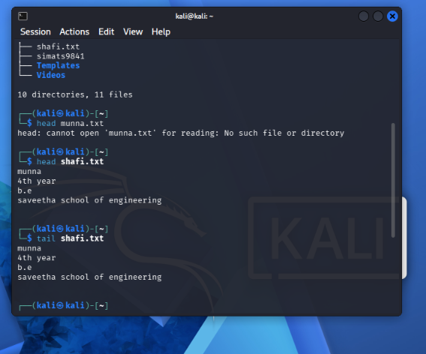

Experiment 4

Directory and File Display Commands

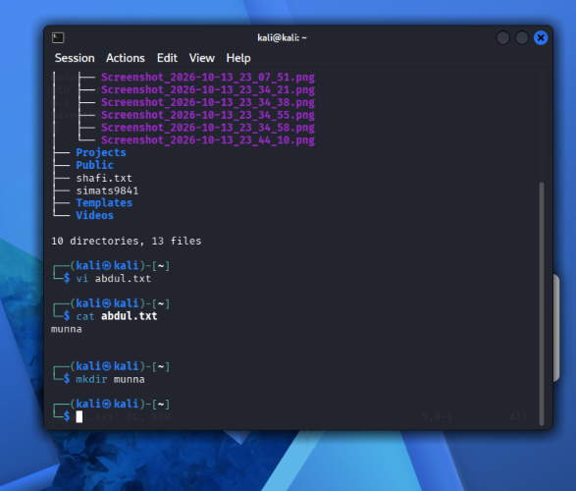

Experiment 5

System Information Commands

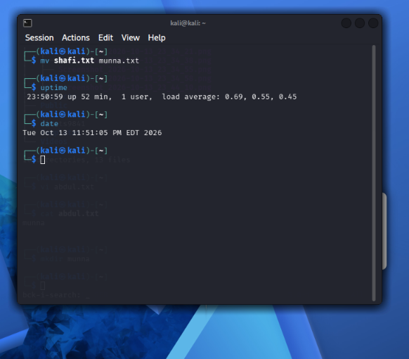

Experiment 6

File Creation and Download Commands

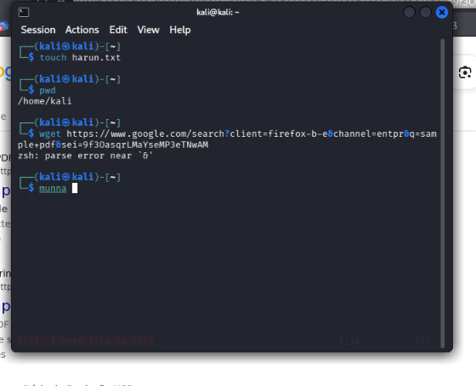

Experiment 7

Navigation and Copy Commands

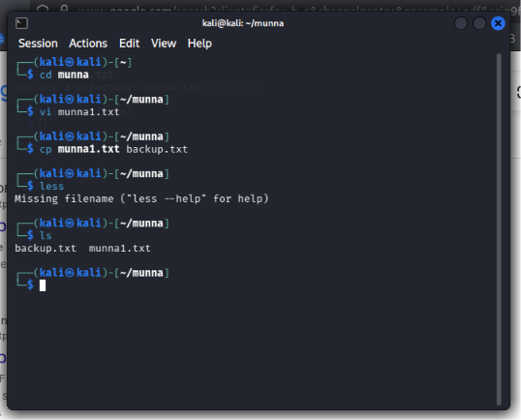

Experiment 8

Nmap Service Version and OS Detection

